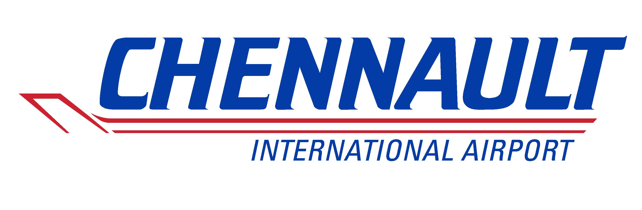

BOARD OF COMMISSIONERS

REGULAR MEETING
Thursday, March 20, 2025
12:00 Noon
CIAA Board Room/3650 Sen. J. Bennett Johnston Avenue/Lake Charles, LA 70615

PROPOSED AGENDA

- Call to order;

- Pledge of Allegiance;

- Roll Call;

- Amendments, additions, and deletions to the Proposed Agenda;

- Announcements/Correspondence;
- Kevin Melton
- Brett Downer – O’Carroll Group
- Gerald Theunissen – Governmental Relations

- Discuss and take appropriate action to change the date of the April 2025 Regular Board Meeting of the Board of Commissioners;

- Discuss and take appropriate action to authorize the Executive Director to enter into a Professional Services Agreement with Don Morris, Consultant, pertaining to tenant lease negotiations;

- Discuss and take appropriate action to authorize the Executive Director to enter into a Letter of Engagement (LOE) for legal services with Dallas K. Kingham, Stockwell, Sievert, Viccellio, Clements, and Shaddock, L.L.P., pertaining to new lease reviews and negotiations;
- Discuss and take appropriate action to authorize the Executive Director to negotiate a lease agreement between Chennault International Airport Authority and Northrop Grumman Corporation;

- Discuss and take appropriate action to authorize the Executive Director to negotiate a lease agreement between Chennault International Airport Authority and Louisiana Millwork L.L.C. (Masonite);

- Motion to enter into Executive Session to discuss potential litigation matters;

- Motion to return to Regular Session;

- Approve the minutes of the February 20, 2025 Regular Meeting;

- Adjournment.

In accordance with the Americans with Disabilities Act, if you need special assistance, please contact the Administration Office at 337-491-9961 describing the assistance that is necessary.

